**Service Level Agreements (SLA) in Cloud computing**

A **Service Level Agreement (SLA)** is the bond for performance negotiated between the cloud services provider and the client. Earlier, in cloud computing all Service Level Agreements were negotiated between a client and the service consumer. Nowadays, with the initiation of large utility-like cloud computing providers, most Service Level Agreements are standardized until a client becomes a large consumer of cloud services. Service level agreements are also defined at **different levels** which are mentioned below:

* Customer-based SLA
* Service-based SLA
* Multilevel SLA

Few Service Level Agreements are enforceable as contracts, but mostly are agreements or contracts which are more along the lines of an Operating Level Agreement (OLA) and may not have the restriction of law. It is fine to have an attorney review the documents before making a major agreement to the cloud service provider. Service Level Agreements usually specify **some parameters** which are mentioned below:



1. Availability of the Service (uptime)



1. Latency or the response time



1. Service components reliability



1. Each party accountability



1. Warranties



In any case, if a cloud service provider fails to meet the stated targets of minimums then the provider has to pay the penalty to the cloud service consumer as per the agreement. So, Service Level Agreements are like insurance policies in which the corporation has to pay as per the agreements if any casualty occurs. Microsoft publishes the Service Level Agreements linked with the Windows Azure Platform components, which is demonstrative of industry practice for cloud service vendors. Each individual component has its own Service Level Agreements. Below are two **major Service Level Agreements (SLA)**described:

1. **Windows Azure SLA –** Window Azure has different SLA’s for compute and storage. For compute, there is a guarantee that when a client deploys two or more role instances in separate fault and upgrade domains, client’s internet facing roles will have external connectivity minimum 99.95% of the time. Moreover, all of the role instances of the client are monitored and there is guarantee of detection 99.9% of the time when a role instance’s process is not runs and initiates properly.
2. **SQL Azure SLA –** SQL Azure clients will have connectivity between the database and internet gateway of SQL Azure. SQL Azure will handle a “Monthly Availability” of 99.9% within a month. Monthly Availability Proportion for a particular tenant database is the ratio of the time the database was available to customers to the total time in a month. Time is measured in some intervals of minutes in a 30-day monthly cycle. Availability is always remunerated for a complete month. A portion of time is marked as unavailable if the customer’s attempts to connect to a database are denied by the SQL Azure gateway.

Service Level Agreements are based on the usage model. Frequently, cloud providers charge their pay-as-per-use resources at a premium and deploy standards Service Level Agreements only for that purpose. Clients can also subscribe at different levels that guarantees access to a particular amount of purchased resources. The Service Level Agreements (SLAs) attached to a subscription many times offer various terms and conditions. If client requires access to a particular level of resources, then the client need to subscribe to a service. A usage model may not deliver that level of access under peak load condition.

**SLA Lifecycle**



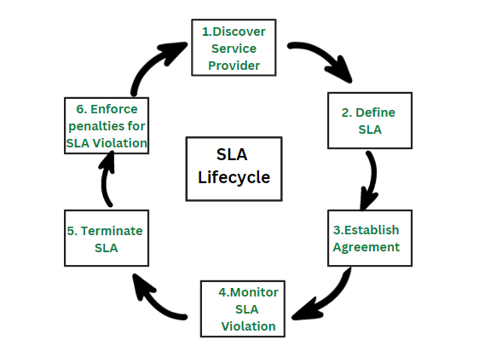



**Steps in SLA  Lifecycle**

1. **Discover service provider:** This step involves identifying a service provider that can meet the needs of the organization and has the capability to provide the required service. This can be done through research, requesting proposals, or reaching out to vendors.
2. **Define SLA:** In this step, the service level requirements are defined and agreed upon between the service provider and the organization. This includes defining the service level objectives, metrics, and targets that will be used to measure the performance of the service provider.
3. **Establish Agreement:**After the service level requirements have been defined, an agreement is established between the organization and the service provider outlining the terms and conditions of the service. This agreement should include the SLA, any penalties for non-compliance, and the process for monitoring and reporting on the service level objectives.
4. **Monitor SLA violation:**This step involves regularly monitoring the service level objectives to ensure that the service provider is meeting their commitments. If any violations are identified, they should be reported and addressed in a timely manner.
5. **Terminate SLA:**If the service provider is unable to meet the service level objectives, or if the organization is not satisfied with the service provided, the SLA can be terminated. This can be done through mutual agreement or through the enforcement of penalties for non-compliance.
6. **Enforce penalties for SLA Violation:** If the service provider is found to be in violation of the SLA, penalties can be imposed as outlined in the agreement. These penalties can include financial penalties, reduced service level objectives, or termination of the agreement.

**Advantages of SLA**



1. **Improved communication:**A better framework for communication between the service provider and the client is established through SLAs, which explicitly outline the degree of service that a customer may anticipate. This can make sure that everyone is talking about the same things when it comes to service expectations.



1. **Increased accountability:**SLAs give customers a way to hold service providers accountable if their services fall short of the agreed-upon standard. They also hold service providers responsible for delivering a specific level of service.
2. **Better alignment with business goals:** SLAs make sure that the service being given is in line with the goals of the client by laying down the performance goals and service level requirements that the service provider must satisfy.



1. **Reduced downtime:** SLAs can help to limit the effects of service disruptions by creating explicit protocols for issue management and resolution.
2. **Better cost management:** By specifying the level of service that the customer can anticipate and providing a way to track and evaluate performance, SLAs can help to limit costs. Making sure the consumer is getting the best value for their money can be made easier by doing this.



**Disadvantages of SLA**



1. **Complexity:** SLAs can be complex to create and maintain, and may require significant resources to implement and enforce.



1. **Rigidity:** SLAs can be rigid and may not be flexible enough to accommodate changing business needs or service requirements.



1. **Limited service options:**SLAs can limit the service options available to the customer, as the service provider may only be able to offer the specific services outlined in the agreement.
2. **Misaligned incentives:** SLAs may misalign incentives between the service provider and the customer, as the provider may focus on meeting the agreed-upon service levels rather than on providing the best service possible.



1. **Limited liability:**SLAs are not legal binding contracts and often limited the liability of the service provider in case of service failure.

